THE JEFFERSONIAN GAZETTE
THOMAS JEFFERSON CHAPTER
FALL ISSUE – 2019
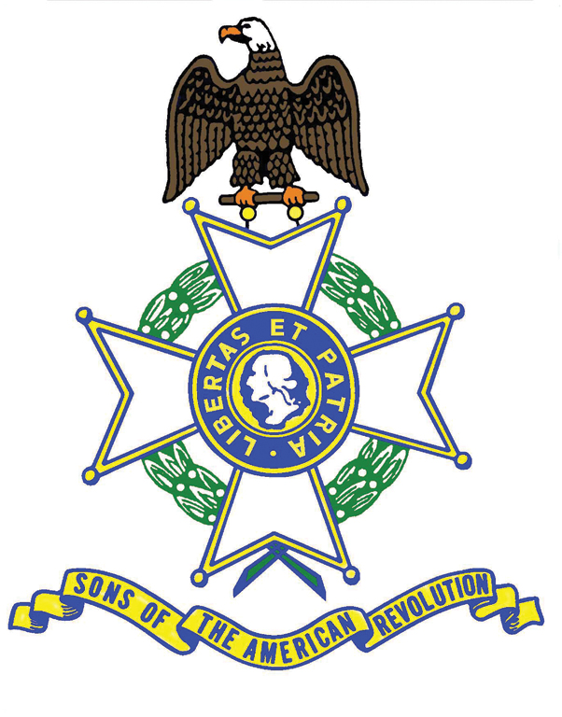
President’s Message
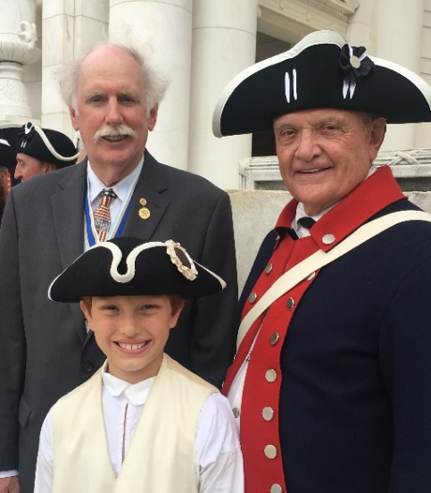
Compatriots: As this Gazette clearly illustrates, your President and First Lady, like the Chapter itself, has been busy in support of the SAR cause of historical and patriotic education, locally, around the State and in adjacent States. Some highlights are shared in this Message, beginning with the O’Kelley family participating in the March to the Tomb at Mount Vernon on a hot July Fourth. We traveled afar for the grave marking, and 247th anniversary NSSAR Ceremony, at the Blue Licks Battlefield Memorial Park in Carlisle, Kentucky. Jan and I loved hosting the Chapter Garden Party, enjoying record attendance, including the current VASSAR President and 1st Vice President as our honored guests.
Jan and I were especially gratified to see our grandson, Blake Branch, participating with the Color Guard at a Wreath Laying ceremony at the Tomb of the Unknown Soldier at Arlington National Cemetery (pictured here with PG Manning and on page 5 of the National Fall 2019 edition of SAR Magazine). We enjoyed our first NSSAR Leadership meeting in Louisville where we experienced another level of the SAR and visited the NSSAR Headquarters and Museum.
On November 8, I presented a talk on “James Monroe and the Battle of Trenton” at the James Monroe Chapter of SAR in Warsaw, Virginia. On November 14, Pat Kelly, VASSAR 1st VP Bill Schwetke, and I presented the forthcoming “2020 NSSAR Congress” program to the Richmond Chapter. Honoring our Sister organization, on November 16, the O’Kelleys and Kellys, attended a DAR Multi-Chapter National Defense Luncheon at Lake of the Woods, Va.
I want to thank you all for a record turnout for the wonderful Ladies Holiday Luncheon at the Greencroft Club. Of special note, our Compatriots collected five large bags of Christmas gifts for veterans at Maguire VA Hospital in Richmond. Well done gentlemen.
Encourage your sons and grandsons, daughters and granddaughters to participate at SAR events with you. They are our future. Thank you for allowing me to continue to serve as your President. Merry Christmas, Happy Holidays, and Happy New Year. Semper Fi, Jim O’Kelley
-2- PAST EVENTS
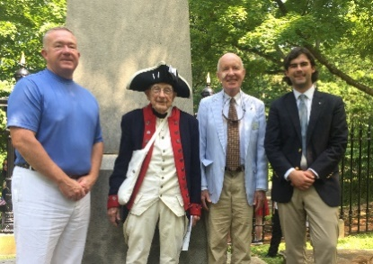
July 4 Independence Day

The Chapter thanks these Compatriots for joining with the DAR and C.A.R. to celebrate the birth of our Country. Chapter VP David Cook (on left) gave a rousing talk titled, "South Carolina in the American Revolution" and the success of the militias in turning the tide against the British and their Tory allies.

Sept. 8 Chapter Fall Picnic
With over 65 in attendance, the Chapter wishes to extend its gratitude to our hosts, Jan and President Jim O’Kelley. On a beautiful day, in a gracious home, with a terrific Mission BBQ dinner, everyone thoroughly enjoyed themselves. Pictured at left below is VASSAR President “Judge” Peter Davenport inducting Compatriot Kevin White.
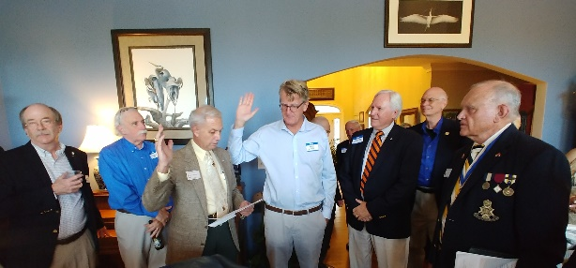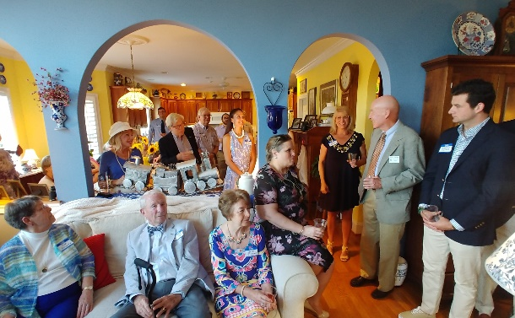
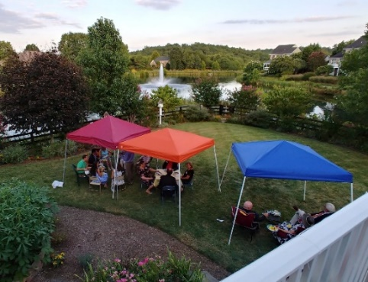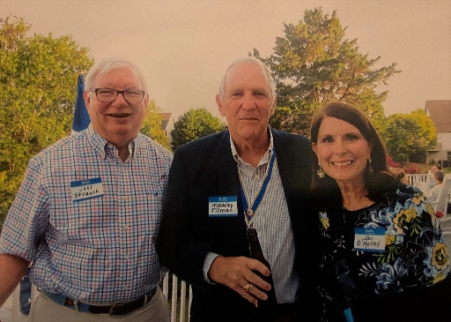

Sept. 13,14 VASSAR Semi Annual – Fairfax
Seen below left are President O”Kelley, NSSAR President General Jack manning, and TJ Compatriots and Past VASSAR Presidents Williams and Kelly. Below right is President “Jim” giving a summary of

-3-
the more salient achievements of our Chapter and well as “just a couple” of jokes from his endless repertoire. The Chapter thanks these Compatriots for attending what was an excellent meeting.
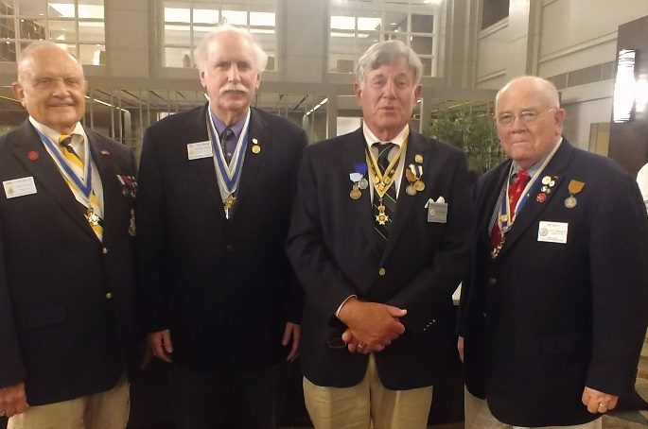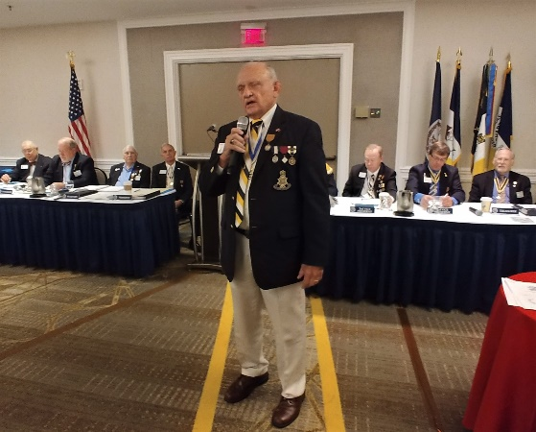
Oct. 8 Chapter Breakfast
We had a full house in the Pine Room at Farmington. After a hardy breakfast, the first order was a symbolic passing of the SAR “Spirit of ‘76” (passing of the bacon) from the oldest member present at 90 years young, Dr. Ken Wallenborn and the youngest, Bailey Friedman. There followed an induction of new member William Calary by Past VASSAR President Pat Kelly. Pat gave us a stirring presentation of what he titled, the
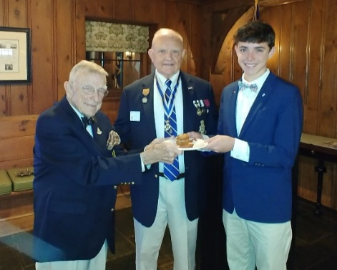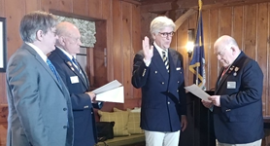
“Spirit of the Doughboys” – about the two million American soldiers who fought primarily alongside the French in the Champagne area near Verdun during the Great War. 116,000 of our boys didn’t come home. He reminded us of the story of “Lafayette, we are here” ("Lafayette, nous voilà") spoken by Col. Charles Stanton at the tomb of the great French hero of the American Revolution in Paris at a ceremony on July 4th 1917.
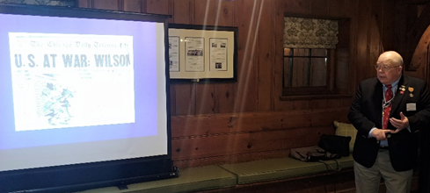
-4-
October 12
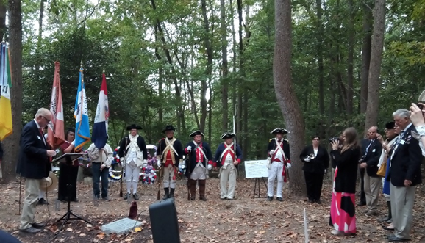
Past VASSAR President, current VASSAR Trustee Pat Kelly, represented the Chapter at a William Grayson Chapter Revolutionary War soldier grave marking, which earns the Chapter points for the Americanism report which all Chapters in the nation must fill out annually and submit by year-end.

Oct. 18/19 Yorktown
Pictured below left are President Kelley, President General Manning, Past VASSAR President Kelly and current VASSAR President Davenport. Below right President and First Lady O’Kelley honoring the grave of Virginia Planter, Soldier and Governor at the time of Yorktown Surrender, Thomas Nelson, Jr.
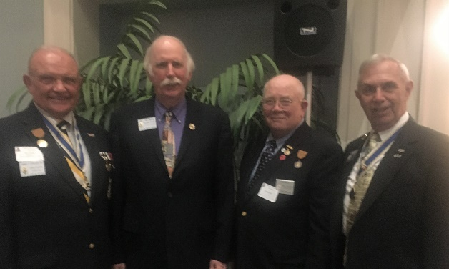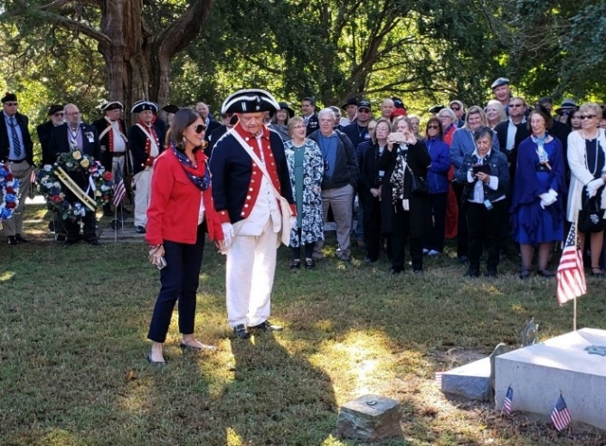
On left, President Jim is pictured with TJ Compatriot Thomas Nelson IV, the Governor’s direct lineal descendant. At center, Kelly, and O’Kelley with past Chapter President Mark Day. At right, Pat Kelly.
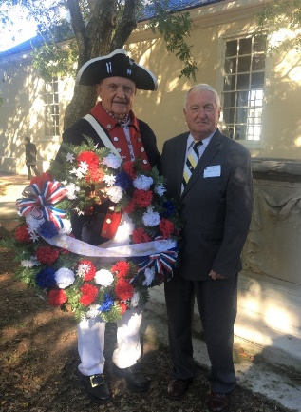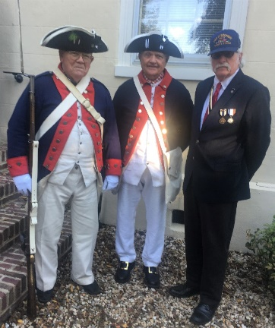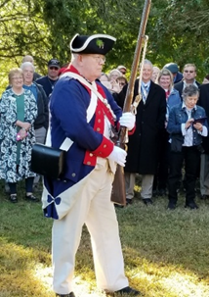
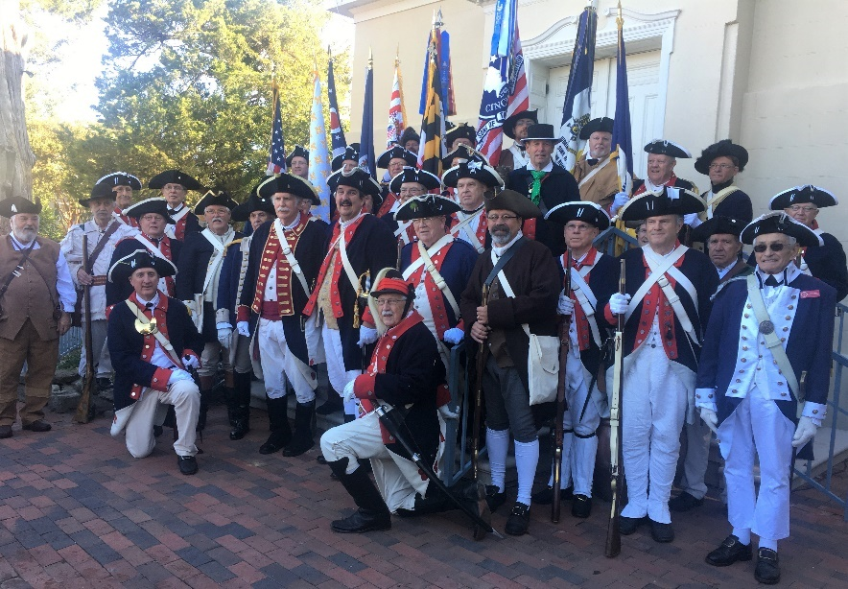
-5-

Yorktown Color Guardsmen, VASSAR and surrounding States’ Guardsmen – a grand site.

Nov. 6 Veterans’ Day Program – William Monroe High School, Greene County
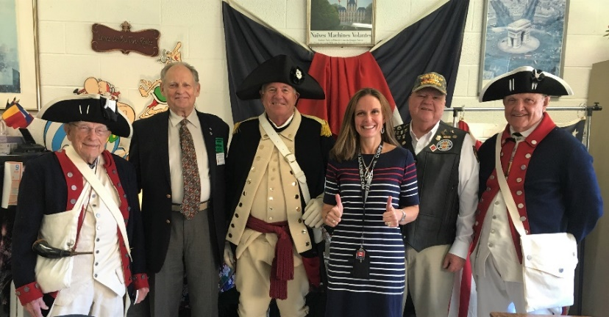
Thanks go to Tara O’Kelley Friedman, the French Teacher and daughter of Chapter President O’Kelley, for organizing this event, giving Compatriots Wallenborn, Garland, Williams, O’Kelley and Sgt. Joel Warren the opportunity to interact with the students about the meaning of Veterans’ Day. President O’Kelley stayed on and gave them a lesson in U.S. Flag (s) history. Bravo Jim!

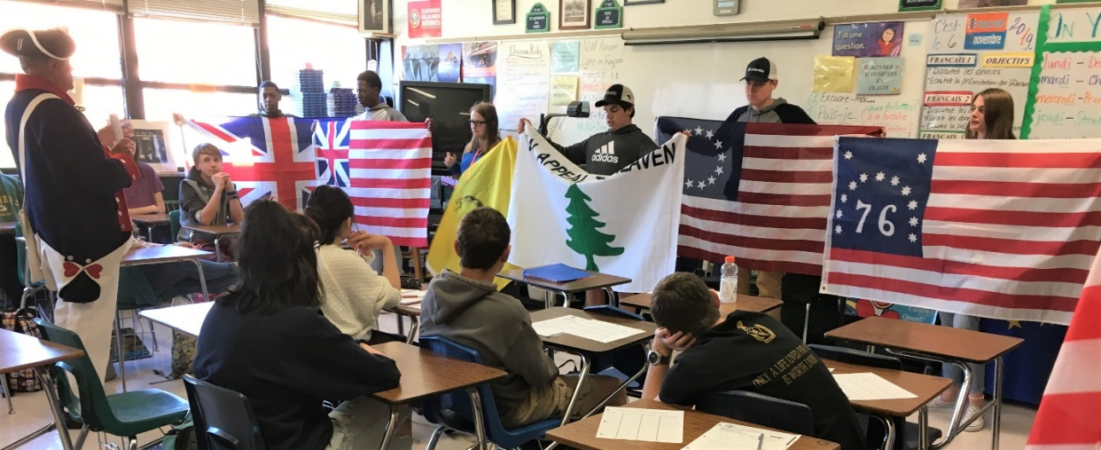

-6-
Nov. 8 Grave Marking of Capt. Peter Northern – James Monroe Chapter
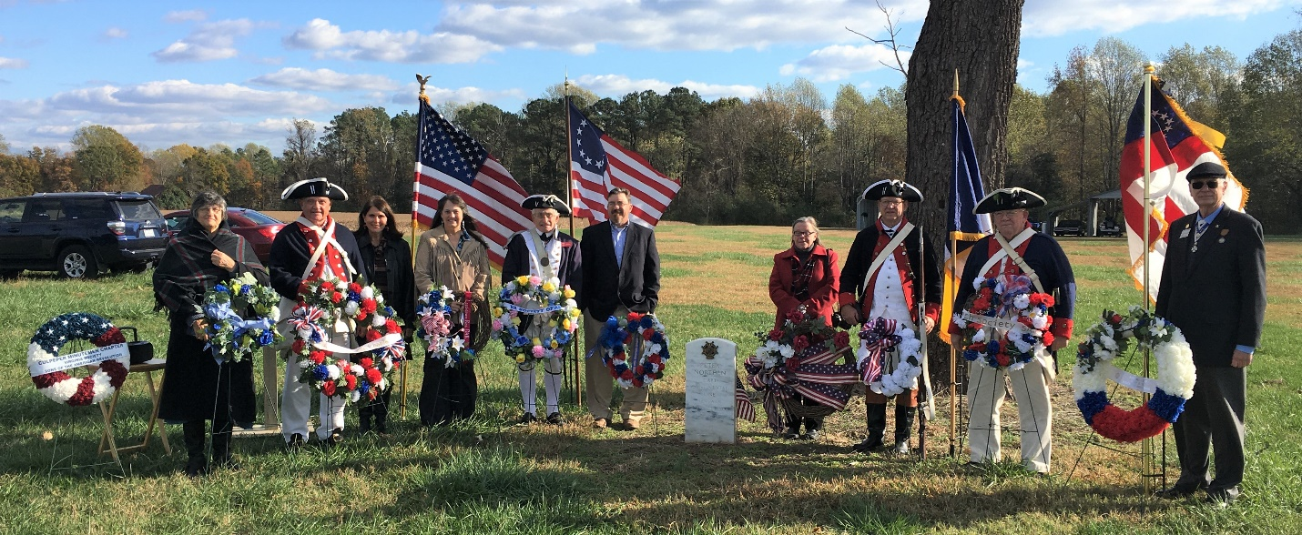
Thank you Chapter President and Jan O’Kelley, and VASSAR Trustee Pat and Jennifer Kelly for supporting this marking over on the Northern Neck. VASSAR 1st VP Bill Schwetke is on the far right.
Nov. 11th Veterans’ Day – First stop, the American Legion ceremony at the County Office Building.
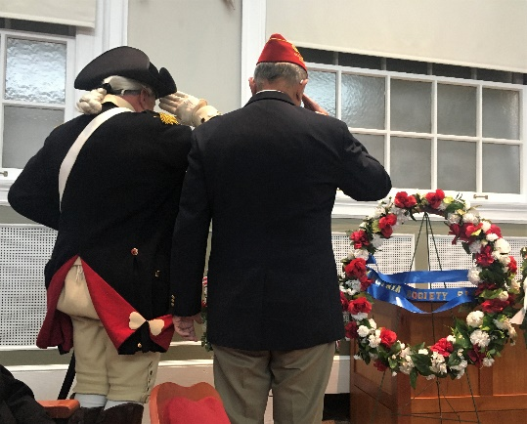
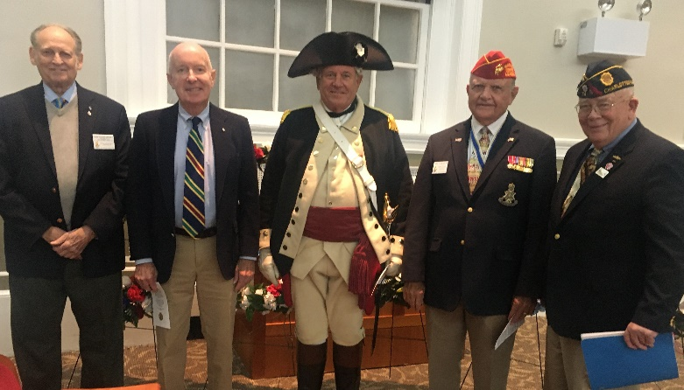

The Chapter thanks Compatriots Garland, Cobham, Williams, President O’Kelley, Kelly and Compatriot Minich (not pictured), who attended this ceremony. The auditorium was packed. Pat Kelly, the “MC”…
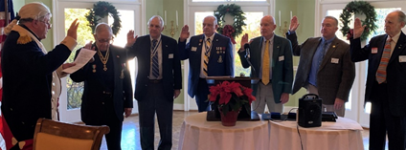
Dec. 7 Chapter Ladies Christmas Luncheon – Greencroft Club
With a crowd of 65 or better Compatriots and guests, after the Invocation, Color Presentation of the Colors, Pledges, and President’s Welcome, Past VASSAR President Williams inducted the 2020 class of Chapter Officers. The Ladies looked stunning in their Holiday dresses.
-7-
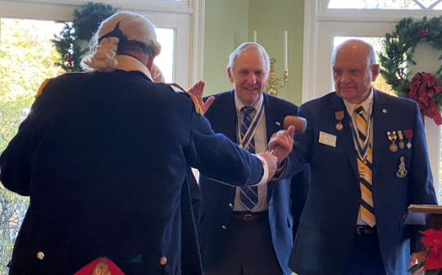
The “historic” Chapter gavel again passed to Jim who now begins his third term as President. The Chapter thanks him for his sterling leadership.

All agreed the Luncheon was beautiful. As the group enjoyed their peppermint stick ice cream, the Program continued with a long
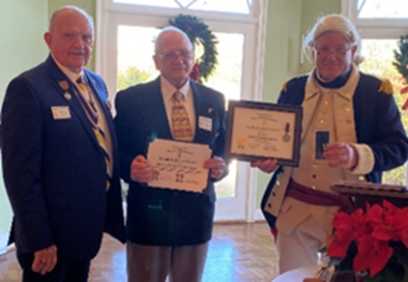
overdue recognition of Compatriot Dr. Gerald Brown, who was awarded by the Chapter the Bronze Good Citizenship Medal for his services working in VA Hospitals caring for several thousand Veterans for over twenty years during the course of his distinguished medical career. He was further recognized by National for his military service in both the Navy and the Marines.
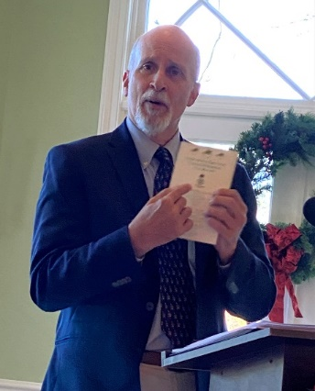

We were then treated to a terrific presentation by Virginia historian Rick Britton. His topic, “Things about Thomas Jefferson you may not have known.” He was right. Even those who think of themselves as quite knowledgeable regarding the Chapter’s namesake, we all learned some fascinating things about the man – some of them quite humorous.

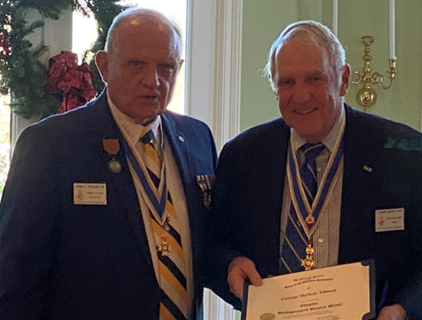
We then moved on for President Jim to personally award two Distinguished Chapter Service Medals, one to Past President Tilman for his “mentoring services to his successor, and the same award to Past President Mark Day (not pictured, he had to leave early) for services in totally revamping the Chapter’s website, giving it a smart and user-friendly look.

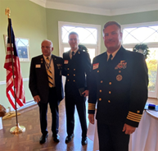
-8-
As is the custom, the Navy’s turn this year, NROTC Commander Captain Kevin Kennedy and Midshipman Colin Hood, the Chapter’s NROTC Silver ROTC Citizenship awardee, addressed the group. Captain Kennedy addressed the state of the current program at UVa. and the exceedingly high caliber of the Midshipmen, academically and physically. Colin Hood (standing next to Jim) as sharp as a razor. He will graduate next year and is off to flight school next summer. He had the swagger of a “flyboy”.

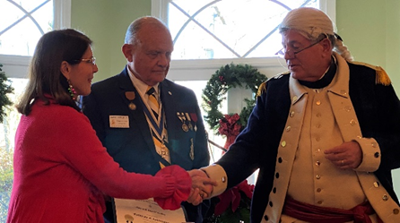
Special awards then followed, first the State-level recognition of outstanding Chapter Service, the Pineapple medal was awarded to First Lady Jan O’Kelley for her VASSAR competition award winning scrapbook (hands down) and her selfless service supporting her husband as he travels hither, thither and yon, in and out of State. Thank you, Jan. The Chapter thinks you are special.

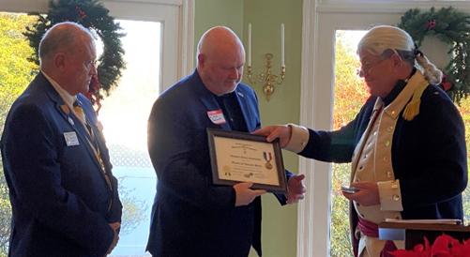
The Chapter was then honored to recognize Michael Henry Kaminski, himself an Air Force Veteran, with a Veterans’ Service award for his leadership in organizing many Veteran-support events, a 5K “Fundraising” run for example, or taking Veterans on Memorial Day to the WWI Bedford Memorial, and countless other ways in support of our local Veterans for many years.
Chapter President O’Kelley then inducted our newest member, David Rusher, raising our total to 116, and then presenting to Stephen Millard, a recent inductee, his NSSAR Certificate of Life Membership.
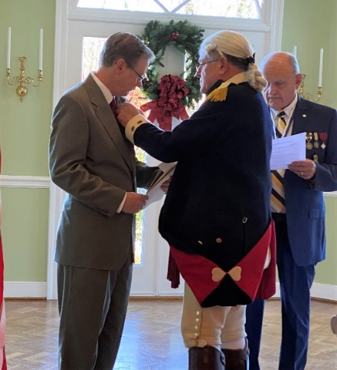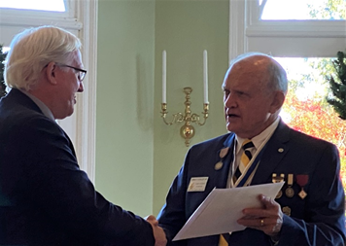
-9-
Granddad took special pleasure in recognizing his grandsons, Bailey Friedman and Blake Branch with awards for two and one year, respectively, of Color Guard service. Made us all smile with pride.
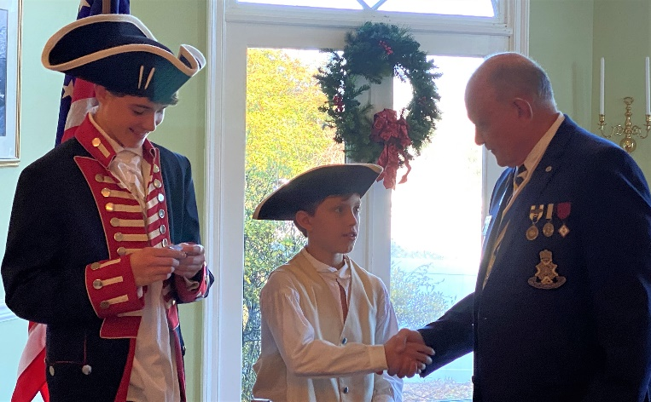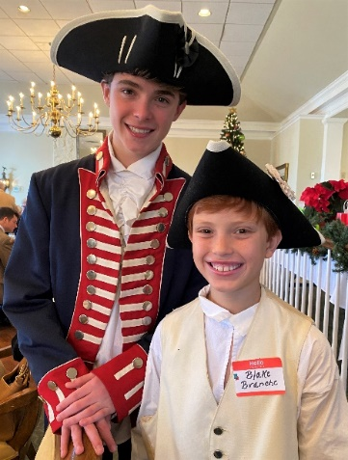
Dec. 9 The Evolution of American Flags – Westminster Canterbury of the Blue Ridge Retirement Center
Led by Chaplain Minich, now a resident, and assisted by Compatriots O’Kelley, Cobham and Williams, a group of some 50 residents were instructed in the history of United States flags, beginning with the Union Jack when we were still British subjects. They seemed to be fascinated with the story, including the story and symbolism of the proper folding of Old Glory.
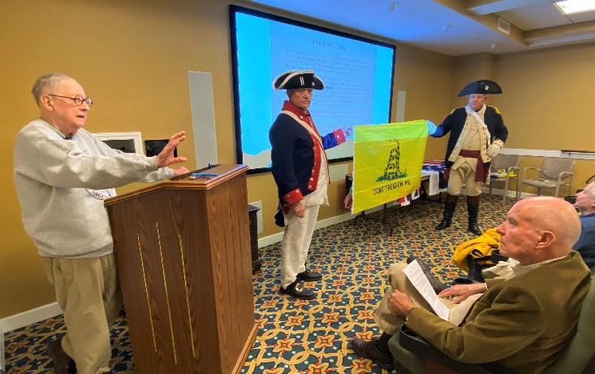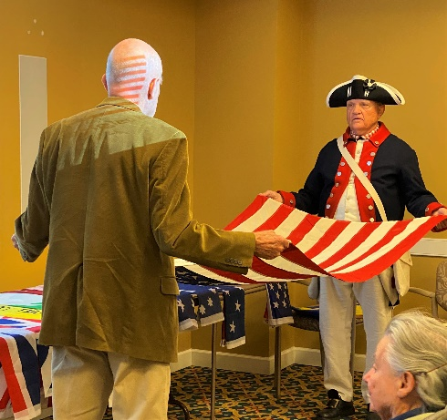

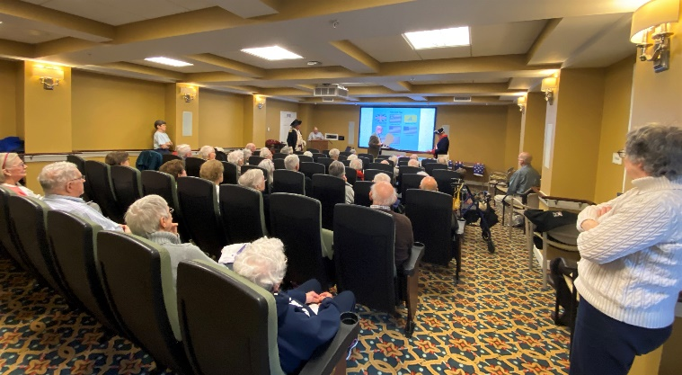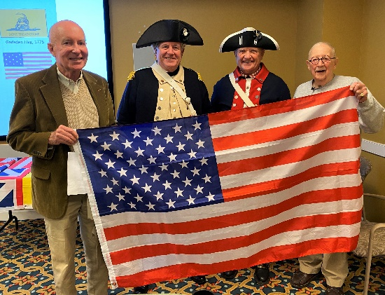
-10-
Dec. 14th – Wreaths Across America
President O’Kelley, together with his grandsons and Guardsmen, Bailey Friedman and Blake Branche, presented a wreath at the Vietnam Memorial at noon and met Compatriot Williams at President Monroe’s Highland for another presentation at 1:00. This is a NSSAR-supported event all across America. East of the Mississippi, the wreaths are underwritten by the Mission BBQ organization which operates in over 80 locations, including here now in Charlottesville. The ceremony is intended to pay homage to those who have given the “full measure” and MIAs in service to a a free Nation, the United States of America. Huzzah!
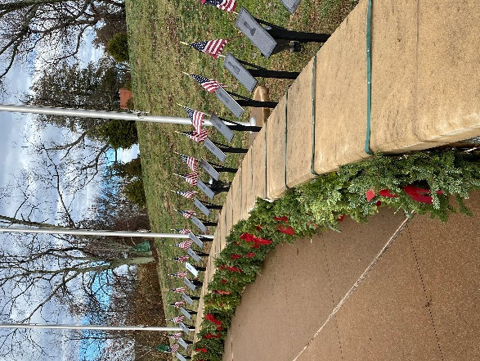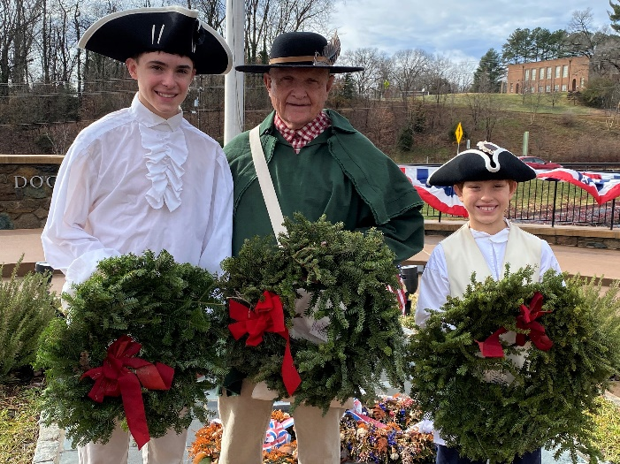

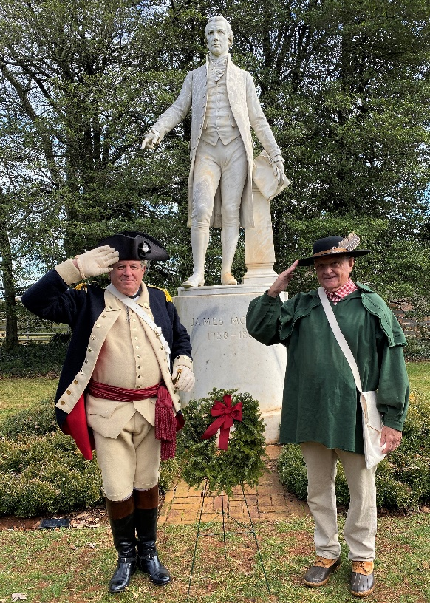
-11- VASSAR NEWS
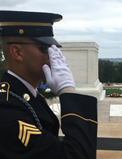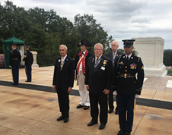
President Peter Davenport (front left), NSSAR President General Jack Manning (rear middle) at the Tomb of the Unknown Soldier.
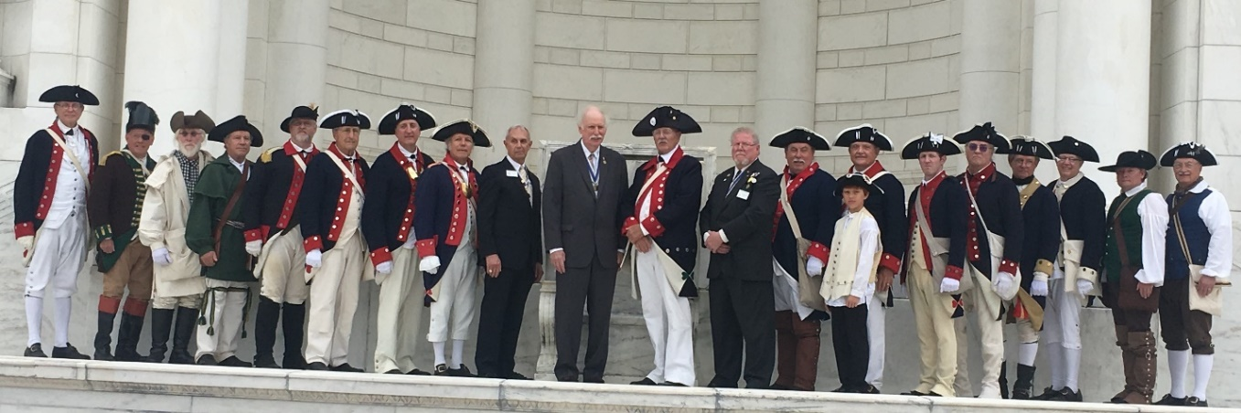
President General Jack manning, assisted by VASSAR President Peter Davenport at Arlington Cemetery. Young TJ Compatriot Blake Branch present and accounted for, with his grandfather, TJ President James O’Kelley right behind him. September 14, 2019.
NSSAR NEWS – National will meet in California in July 10-16 of 2020 in Richmond. Stay tuned. Pictured below are VASSAR members and their Ladies at Leadership in Louisville at the end of September, including Compatriots Kelly and O’Kelley and their Ladies.
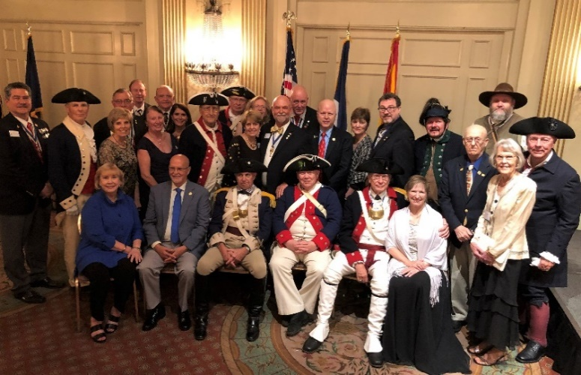
-12-
NECROLOGY – Tom Conner (1/10/19), Alvin Ash (7/7/19), Jacob Peters (7/13/19)
OFFICERS – James O’Kelley, President; Geoff Cobham, Secretary and Event Coordinator; David Cooke, Vice President, Joel Strauch, Treasurer, Assist. Treasurer, Mackey Tilman, Rev. Cn. Henry Minich, Chaplain; Mark Chapman, Registrar; Pat Kelly, Historian; Harvey Hague, Chancellor; Dr. Ken. Wallenborn, Surgeon; Phil Williams, Publicist, and Joseph Garland, Photographer.
BOARD OF MANAGERS – Compatriots O‘Kelley, Tilman, Cobham, Kelly, Wallenborn; Williams; Minich; Hague; Chapman, Strauch. Emeritus: Lea Schultz
COLOR GUARD - P. Kelly (Chair), M. Day, K. Wallenborn, J. O’Kelley, P. Williams, B. Friedman, B. Branche

-13- COMING EVENTS (MARK YOUR CALENDARS for 2020) [Nationally Sanctioned Events in Bold]
Jan. 9 BOM, 4:00
Feb. 7,8 VASSAR AGM, Richmond
Feb. 14,15 The Crossing of the Dan, South Boston, Va.
Mar. 5 BOM
Mar. 7 Chapter Breakfast, Farmington, 8:45
Mar. 14 Battle of Guilford Court House
Mar. 16 James Madison Montpelier, Wreath Laying, 1:30
3:00 Compatriot Williams giving a Book Talk at Montpelier
April 13 Thomas Jefferson Birthday, Wreath Laying, 9:00
April 18 Graves Mtn. Multi-Chapter Luncheon, 11:00
April 24 Vietnam Memorial, Dogwood Festival
May 7 BOM
May 9 The Raid on Martin’s Station
May 25 Memorial Day, The Pavilion, 11:00
June 6 Chapter Breakfast with the Ladies, Farmington, Old Main, 8:45
July 4 Monticello, Naturalization Ceremony, 9:00, Jouett DAR-TJ Jefferson Graveside, 10:45
July 10-16 NSSAR AGM Richmond
Aug. 7,8 Annual Middle States Meeting
Sept. 3 BOM, 4:00
Sept. 6 Chapter Picnic
Sept. 12 VASSAR Semi-Annual, Halifax County
Oct. 3,4 Battle of Point Pleasant, Battle of Kings Mountain
Oct. 10 Chapter Breakfast, Pine Rm, Farmington
Oct. 19 Yorktown Commemoration
Nov. 11 Veterans’ Day ceremony, County Office Building, 11:00
Dec. 5 Chapter Christmas Luncheon with Ladies, Greencroft, 11:30 Social, 12:00 Luncheon
Dec. 12 Wreaths Across America – Dogwood Vietnam Memorial, 12:00, Monroe’s Highland, 1:00

